***AMSAT***



2

**RadFxSat-2 Shock Analysis**

## Document Change Log

|  |  |  |  |
| --- | --- | --- | --- |
| **Revision** | **Date** | **Author** | **Change Log** |
| 1 | May 12, 2018 | R Davis | Initial release |
| 2 | May 27, 2018 | R Davis | Added “The shock requirement is verified by analysis.” |

## Satellite Team Responsible Engineer

|  |  |
| --- | --- |
| **Author** | **Contact** |
| R Davis | KF4KSS@AMSAT.org |

**Purpose:** As required submission at MRR for RadFxSat-2 on NASA VCLS ELaNa XX, analytic method is presented to justify “No shock test required” condition. Therefore, it is reasonable that RadFxSat-2 will survive the launch and ascent shock environment, and that forgoing a shock test is low risk and a reasonable approach. The shock requirement is verified by analysis.

Table 3-19 is the more accurate response than Figure 3-19, since Table 3-19 is the MPE of the input to the integrated payload group (adapter structure). Additionally, a minimum of two bolted joints provide attenuation. [Source: communication, Jason Armstrong, Trisept]

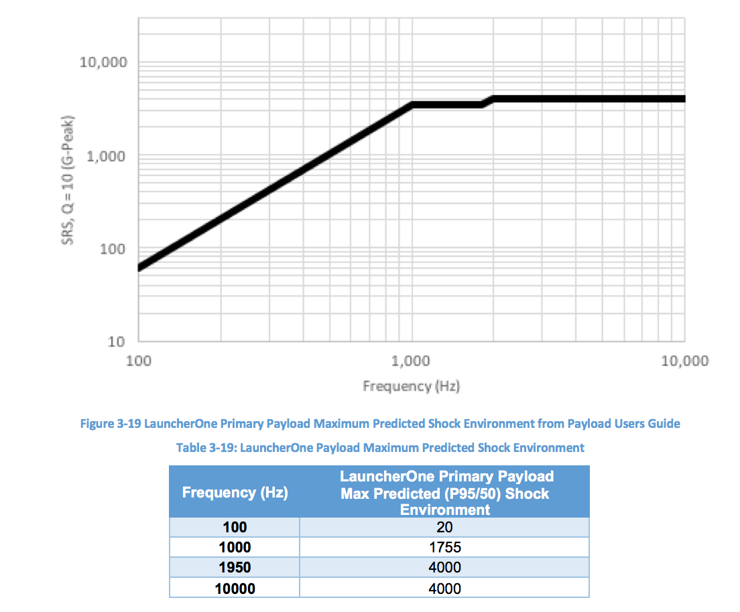

NASA-STD-7003 Pyroshock Test Criteria suggests the attenuation due to structural joints ranges from 20 to 75 percent, depending on the type of joint and the manner in which it changes the shock transmission path.

NASA-CR-116406 Aerospace Systems Pyrotechnic Shock Data present rules of thumb for structural interface percent reduction of shock, including 30% for matched angle (3.2 Effects of Structural Interfaces), and 70% for shock perpendicular mounting of similar structure size (Figure 3.10 Effects of Structural Interfaces).

The 1st joint (shock source to integrated payload group) is assumed as matched angle.

The 2nd joint (integrated payload group to dispenser) is assumed as perpendicular and similar size.

Additional joints may be present, and a 3rd joint could be considered in this analysis.

However, additional joints are ignored here.

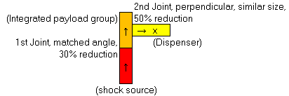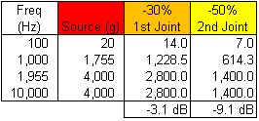

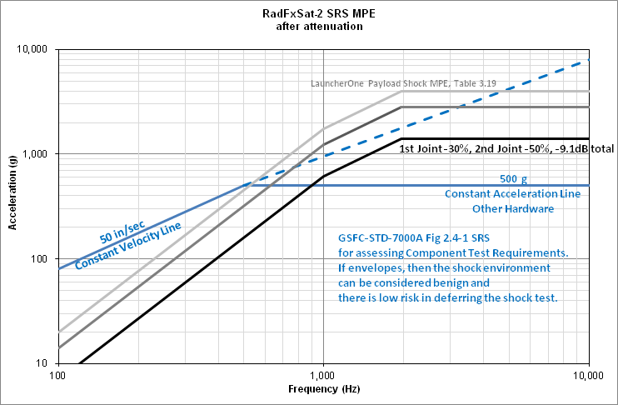

The attenuation of two bolted joints lowers the SRS MPE of RadFxSat-2 below the GSFC-STD-7000A Fig 2.4-1 curve considered benign and therefore a low risk in deferring the shock test.

**Conclusion:** Therefore, it is reasonable that RadFxSat-2 will survive the launch and ascent shock environment, and that forgoing a shock test is low risk and a reasonable approach.

The shock requirement is verified by analysis. “No shock test required.”

**Compliance Certification**

I certify that RadFXSat-2 is verified by analysis. “No shock test required”.

Sincerely,

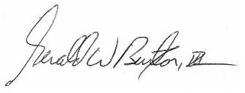

Gerald Buxton

Vice President – Engineering

AMSAT

(817) 573-2465